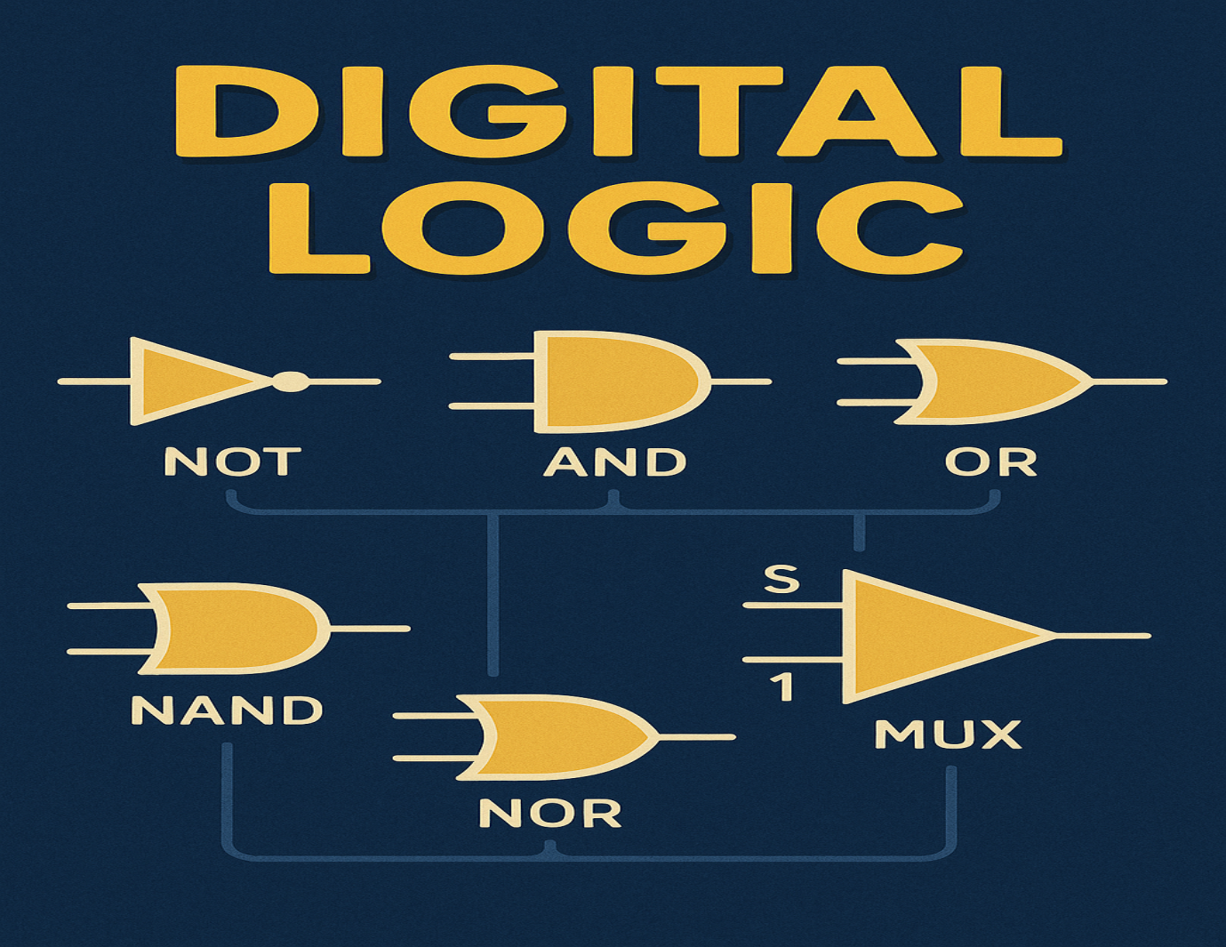

Digital Logic

By Jawad Jammoul

